
Saturn V Gymnastics Centre

TrampolinecoachUK incorporating, HSTC, Aerial TC,
Saturn V (Via License)

Highlighted in Grey Non-Compulsory but would be appreciated Highlighted in Yellow All Require completing
This Medical and Membership form is applicable for Saturn V Gymnastics Centre & HSTC, which is operated on a community basis by TrampolineCoachUK. This form complies with current regulations. Please note that to keep up with any policy changes, including those regarding data usage, are subject to change at any time. However, while you are with the club, we will notify you as soon as reasonably possible, or within 28 days.

If you could please tick this box if you are happy to receive information by 3rd parties picked by the club
If agree how would you like to receive Txt E­Mail Post (if you wish to stop at any time just contact the club)

Please note that due to insurance liability we have to retain the membership form until the participant is 21 or 03 years from Date of leaving club. Would you be happy for us to digitalise this form to allow for easy storage of your participant. Yes No (If no we shall retain it in hard copy in line with secure storage.

First Name (Participant)*: _______________ Surname (Participant) :________________ DOB:_________

Contact Name:_____________ Contact No*. _________________ Relationship to child*: ______________

Address *: __________________________________________________________Postcode*: __________

Contact No. Mobile*:__________________ I permit the club to store my data Signed*: ________________

Member Details: Please Note * Data is required if, for any reason, you cannot contact the club

E-Mail: ________________@ _____________________ (This will be used for information / newsletters Inc. fees do you agree to be contacted in this way? Yes No Only for Newsletters

I also agree to be contacted on above number/s in case any other items/information need to be confirmed. If you don’t agree it does mean you can miss out on vital information that may be important to you / your participant (This includes cancelled sessions at short notice) Yes No

Additional Contact Number: (this will be used for emergencies only if you cannot be reached)
(This Needs to be signed by the named person to allow us to store their data.)
I agree to be contacted in emergency for above named child: Signed*: ____________ Date*: ________

Contact Name*: ___________________ Contact Number*________________ Relationship: __________

Consent (Its important for you to fill in the following sections to ensure safety for all)
…
Consent for Photography / Video: I give permission for photographs / Video** to be taken by the officials of the club at sessions or competitions for club use: Yes No For use on our website Yes No . Club Information Boards / Leaflets / Promotions Yes No Signed*:________________ Date*: _______
** Please note if non club & club members are incidentally captured due to being in the hall their image may be used.

Consent Enter Competitions: I give permission for the participant to be entered into appropriate / suitable
competitions (info and confirmation will be required at the time before proceeding) Yes No

Consent for Leaving: I give permission for my child to leave the hall to come and meet me (if not, we will attempt to keep them in the hall until you collect, unless they force their way out or leave, as we are unable to restrain them. Yes No

Consent for using toilet: I give permission for my child to leave the hall to use the toilet (if no permission is granted, they will not be able to leave the hall for the toilet). We are unable to chaperone them Yes No
Please continue on next page (PTO)
HEALTH & SAFETY INFORMATION FOR YOU
- Qualified coaches/teachers where applicable run all sessions of the club. Participants will be instructed in an approved manner to ensure safe progressions are used, and the correct mechanics of the skills will be taught to ensure progressions and safety for all. It is therefore essential that participants adhere to the instructions of their coach/leader and all club rules are adhered to!
- The club and governing body strive to make the sports of Gymnastics, Trampolining and associated disciplines as safe as possible; however, as with any vigorous athletic activity, there’s a risk of injury. In particular, our sports involve repetitive contact with trampoline/floor whilst often performing inverted skills in a variety of landing positions.
- All the clubs' Coaches, Assistants, Volunteers who are of adequate age have full clearance and an Enhanced DBS disclosure (formerly Criminal Records Bureau Check)
- The club and staff work in accordance with all regulatory guidelines for child protection, as well as requirements for a welfare officer. We believe that safe sport for all participants is essential!
HEALTH & SAFETY INFORMATION FOR US
- PARENTAL CONSENT: I authorise the coaching staff to seek medical treatment for injury sustained by the participant whilst participating in Trampolining, Gymnastics or associated activities. In the event I or the additional contact (Inc whilst they are awaiting for them to arrive at the venue), I hereby authorise the doctor and or hospital / qualified first aider / medical staff to perform any necessary emergency treatment for any injury Yes No
If you cannot provide the medical authorisation, please specify the procedure we should follow.

*** Please note non-standard consent may prohibit participation, but will be considered by the head coach / club committee, and we may have to consult with our insurance provider to ensure club and participant safety!
Non Standard Consent approved by Head Coach / Committee: _________________ Date: _____
- Please advise us of any ongoing illnesses or disabilities which could affect the participant’s performance, behaviour, or behavior/health. Please also advise us of any short-term problems of a similar nature. Such conditions would include allergies or anything that may affect balance.

_______________________________________________________________________________
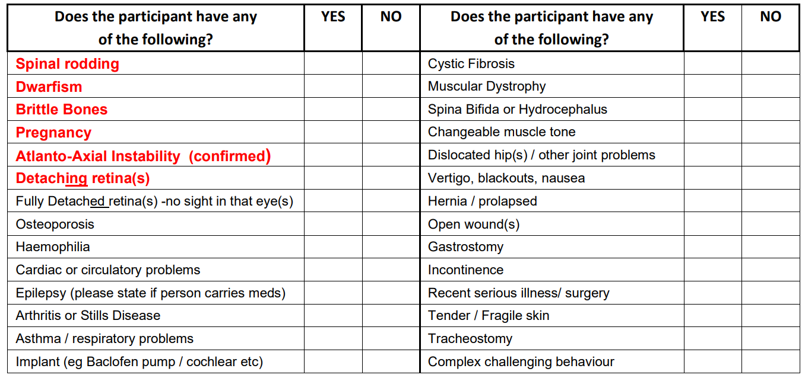

I / We being legal guardians of _________________ (or if over 18 _______________) I have read and understood the risks of the activities and confirm that I / We have received, read and understood and will abide by the club and governing body rules. The named participant is in good health and physically capable of participating in the club and associated activities.

Signed: ___________________ (Parent / Guardian) Print Name: ___________________ Date: ______

Office Use: Awards Completed:

