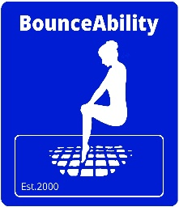

Highlighted in Grey: Non-Compulsory, but would be appreciated. Highlighted in Yellow: All require completing

Inc. B4ALL CIC, HSTC
www.bounceability.co.uk
BounceAbility Trampoline Centre

This Medical and Membership form is applicable to BounceAbility Trampoline Centre. B4ALL CIC & HSTC. This form complies with current regulations. Please note that the policy regarding data usage is subject to change at any time. However, whilst you are with the club, we will notify you as soon as reasonably possible, or within 28 days.

If you could please tick this box if you are happy to receive information from 3rd parties picked by the club
If you agree, how would you like to receive Txt E­Mail Post (if you wish to stop at any time, just contact the club)

Please note that, due to insurance liability, we must retain the membership form until the participant is 21 or 3 years after leaving the club. Would you be happy for us to digitalise this form to allow for easy storage of your participant information? Yes No (If no, we shall retain it in hard copy in line with secure storage.

First Name (Participant)*: _______________ Surname (Participant) :________________ DOB:_________

Contact Name:_____________ Contact No*. _________________ Relationship to student*: ____________

Address *: __________________________________________________________Postcode*: __________

Contact No. Mobile*:__________________ I permit the club to store my data Signed*: ________________

Member Details: Please Note * Data is required if, for any reason, you cannot contact the club

E-Mail: ________________@ _____________________ (we will use for newsletters, and essential information inc. regular bulletins Do you agree to be contacted? Yes No Only for Newsletters

I also agree to be contacted on the above number/s in case any other items/information need to be confirmed. If you don’t agree, it does mean you can miss out on vital information that may be important to you / your participant (This includes cancelled sessions at short notice) Yes No

Additional Contact: (This can be an alternative Parent, Guardian, Carer/friend or Additional Needs Rep).
(This needs to be signed by the named person to allow us to store their data.)
I agree to be included on mail list and contacted for above named Participant: Signed*: ____________ Date*: ________

Contact Name*: ___________________ Contact Number*________________ Relationship: __________

Consent (It's important for you to fill in the following sections to ensure safety for all)
…
Consent for Photography / Video: I give permission for photographs / Video** to be taken by the officials of the club at sessions or competitions for club use: Yes No For use on our website Yes No . Club Information Boards / Leaflets / Promotions Yes No Signed*:________________ Date*: _______
** Please note that if non-club & club members are accidentally captured due to being in the hall, their image may be used. When it states club, that is for BounceAbility Ltd, B4All CIC, HSTC Sites, Groups, Social Media, etc.

Consent Enter Competitions: I give permission for the participant to be entered into appropriate/suitable
competitions (info and confirmation will be required at the time before proceeding) Yes No

Consent for Leaving: I give permission for The Participant to leave the hall to come and meet me (if not, we will attempt to keep them in the hall until you collect, unless they force their way out or leave, as we are unable to restrain them. Yes No

Consent for using the toilet: I give permission for the participant to use the toilet (if no permission is granted, they will not be able to go to the toilet). We are unable to chaperone the participants. Yes No
Please continue on the next page (PTO)
HEALTH & SAFETY INFORMATION FOR YOU
- Qualified coaches/teachers where applicable run all sessions of the club. Participants will be instructed in an approved manner to ensure safe progressions are used, and the correct mechanics of the skills will be taught to ensure progressions and safety for all. It is therefore essential that participants adhere to the instructions of their coach/leader and all club rules are adhered to!
- The club and governing body strive to make the sports of Gymnastics, Trampolining and associated disciplines as safe as possible; however, as with any vigorous athletic activity, there’s a risk of injury. In particular, our sports involve repetitive contact with trampoline/floor whilst often performing inverted skills in a variety of landing positions.
- All the clubs' Coaches, Assistants, Volunteers who are of adequate age have full clearance and an Enhanced DBS disclosure (formerly Criminal Records Bureau Check)
- The club and staff work in accordance with all regulatory guidelines for Welfare, as well as requirements for a welfare officer. We believe that safe sport for all participants is essential!
HEALTH & SAFETY INFORMATION FOR US
- CONSENT: I authorise the coaching staff to seek medical treatment for injury sustained by the participant whilst participating in Trampolining, Gymnastics or associated activities. In the event I or the additional contact (Inc whilst they are awaiting for them to arrive at the venue), I hereby authorise the doctor and or hospital / qualified first aider / medical staff to perform any necessary emergency treatment for any injury. Yes No
If you cannot provide the medical authorisation, please specify the procedure we should follow.

*** Please note non-standard consent may prohibit participation, but will be considered by the head coach / club committee, and we may have to consult with our insurance provider to ensure club and participant safety!
Non Standard Consent approved by Head Coach / Committee: _________________ Date: _____

NOTE ANY MEDICAL CONDITIONS / BEHAVIOURS / INFORMATION (ADD SHEET IF REQUIRED)

_______________________________________________________________________________
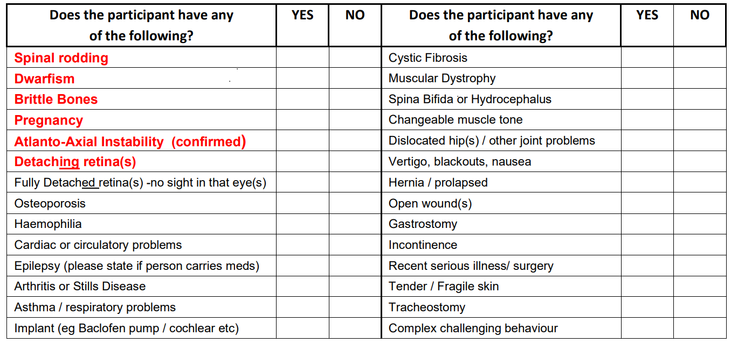

I / We being legal guardians of _________________ (or if over 18 (and legally able to) _______________) I have read and understood the risks of the activities and confirm that I / We understand we must comply with the club and Governing Bodies' rules and regulations. The named participant is in good health and physically capable of participating in the club and associated activities. By signing, we also agree to the centre/club's terms and conditions of use and membership.

Signed: ___________________ (Parent / Guardian) Print Name: ___________________ Date: ______
Office Use: Awards Completed:

